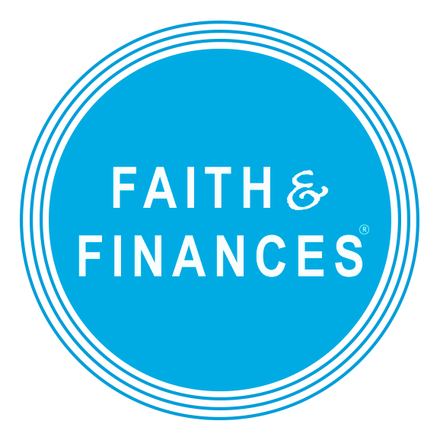

Join our Team!
Become a Faith & Finances Ally for men at The City Mission!

The City Mission has partnered with the Chalmers Center for Economic Development to begin a new kind of learning community at the Crossroads Men’s Crisis Center.

Faith & Finances is a financial education ministry that empowers low-income people with practical money management skills, biblical stewardship principles, and supportive relationships.

Faith & Finances is different from many other financial education programs. It’s not about helping participants achieve wealth or material success. Rather, it aims to empower participants to experience restoration in their finances—and in their relationships.

Allies walk alongside men participating in the Crossroads long-term program. Allies begin to walk with the men during the Faith & Finances class, joining them on their journey. Allies work with a participant, providing encouragement, advocacy, and supportive friendship. Along the way, Allies learn just as much—or more—from participants as they come together to discover God’s design for their money.

We need willing volunteers to...

- Attend and participate in the Faith & Finances financial education course beginning January 9th, 2018 and running 6 weeks, Tuesdays and Thursdays 10AM-11:30AM
- Regularly pray, eat, and spend time with participants
- Assist participants with setting savings goals, reviewing budgets, discussing purchases, etc.
- Follow up with participants during and after the Faith & Finances class, providing encouragement and accountability in reaching their goals
- Commit to being an Ally for at least one year, building relationships with participants and meeting with them regularly.
- Attend our Ally Training Event January 6th from 8AM-NOON at 5310 Carnegie Ave. You will be trained in the dynamics of poverty as well as best practices of mentoring. Breakfast will be provided!

If you are interested in attending our Ally Training Event and becoming a Faith & Finances Ally, please contact Justin Ross at 216-920-4133 or jross@thecitymission.org

